Ashvamedha or Horse Sacrifice for Kingdoms
According to this ritual, a horse was set loose to wander freely. The Raja’s men guarded it. If the horse wandered into other kingdoms and the rajas of those kingdoms stopped it, then they had to fight. However, if they allowed the horse to pass, then they accepted that the raja performing the sacrifice was stronger than them.
Once the horse was back after the fights, if any, a sacrifice was organized honouring and recognizing the raja as being the most powerful king. Specially trained priests performed this sacrifice with an invitation to all other rajas.
In this ritual, the raja who was being revered was given a special seat – either a throne or a tiger’s skin. His wives and sons also had to perform some minor rituals. Every raja had a charioteer who witnessed his exploits in battle and chanted tales of his glory.
All other rajas who were invited had to bring gifts for him. The ordinary people, known as the vish and the vaishya (with the exclusion of shudras), also brought gifts. This ritual transformed the rajas from being ‘Raja of Janas’ to being ‘Raja of Janapadas’. In simpler words, Raja of Janas means king of the people and Raja of janapadas means king of the land where the Janas have settled or king of a kingdom.

Some Archaeological Findings
In their excavations, archaeologists have found many settlements in Janapadas like Purana Qila in Delhi, Hastinapur in Meerut and Atranjikhera near Etah. These excavations revealed that people in these Janapadas lived in huts, reared cattle, grew a variety of crops and also made earthen pots.

Mahajanapadas
Over years some Janapadas gained more importance and relevance than the others. These Janapadas were called Mahajanapadas. Here is a quick look at some of them:
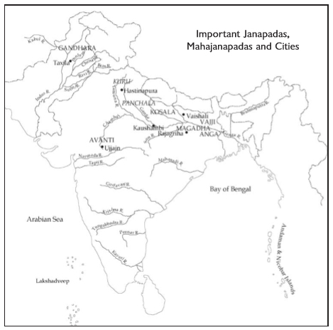
Most Mahajanapadas had a capital city and a fort to protect them. These were huge walls made of stones and wood, possibly to safeguard the kingdoms from attacks from other kings. It is also possible that Rajas made these forts to display their power and richness. Further, managing the Janas was easier when they were living in a fortified area.
It is important to note that building and maintain such a fort requires a lot of materials and labour. Hence, Rajas started appointing armies of young men and paying them salaries.

Taxation in Mahajanapadas
The Rajas of Mahajanapadas needed resources to build forts and maintain armies of soldiers. They couldn’t depend on the occasional gifts brought by people. Hence, they started collecting resources from Janas by means of regular taxes. Here is a quick look at what they collected:
- Since most people were farmers, crops were the first things to be taxed. Typically, the Raja took one-sixth (1/6th) of the produce as tax or Bhaga or share.
- There was a different kind of tax for skilled people. They had to work for the king for a day or two every month without charges as a tax.
- A tax was also levied to hunters, gatherers, herders and trade transactions.

Agricultural Changes During this Period
By now, farmers had already started using wooden ploughshares. During this period, iron ploughshares replaced their wooden predecessors. These helped the farmers since they could turn over the heavy and clayey soil better leading to more grain production.
Also, transplanting of paddy started during this time. Earlier, plants would sprout out of the seeds scattered on the ground. People replaced these seeds with pre-grown saplings leading to increased production. Being physically straining work, slaves (dasas and dasis) and landless agricultural labourers (kammakaras) did this job.

Magadha
In about two hundred years, Magadha became the most powerful Mahajanapada. Rivers like the Ganga and Son flowed through it which provided water, improved transport and helped make the land fertile. Also, some forested parts of Magadha provided:
- Animals like elephants – captured and trained for the army
- Wood for building houses, carts, and chariots.
- There were some iron ore mines in the region as well which helped in making tools and weapons.
Magadha has a long list of powerful rulers like Bimbisara, Ajatasattu, Mahapadma Nanda, etc. These rulers ensured that they captured the other janapadas and increased the span of their kingdoms. Rajagriha or present-day Rajgir in Bihar was the capital of Magadha for many years. Eventually, Pataliputra or present-day Patna became the capital of Magadha.
There is a story about Alexander, from Macedonia in Europe, who wanted to conquer the world. In the Indian subcontinent, he had reached the banks of river Beas and wanted to march eastwards. However, his soldiers refused since they had heard about the powerful Indian rulers with vast armies of foot soldiers and elephants.

Vajji
During the same time, Vajji was under a different kind of government – called the Gana or Sangha. Its capital was Vaishali (Bihar). They way a Gana or Sangha works is – there are many rulers of the janapada. Each ruler is called a Raja. These rajas would perform rituals together and would meet and take decisions after discussion and debate. These assemblies did not allow women, dasas, and kammakaras to be a part them.

